Plant Growth Regulation and Responses

Light intensity, day length, gravity and temperature are major factors that influence plant growth. A tropism is a growth response of a plant to an external stimulus.
A tropism can be positive (the growth response is in the direction of the stimulus) or negative (the growth response is away from the stimulus).
Tropisms are adaptive responses; they increase the plant’s chance of survival and reproduction.. Positive phototropism places the leaves in better light with increase in photosynthesis

Phototropism is the growth response of a plant in response to light direction.
Geotropism is the growth response of a plant in response to gravity.
Thigmotropism is the growth response of a plant to physical contact (touch).
Chemotropism is the growth response of a plant to a particular chemical.
Hydrotropism is the growth response of a plant to water.

Plant Growth Regulators
Tropisms are controlled and moderated by special chemicals called growth regulators. A plant growth regulator is an organic substance that is made in tiny amounts by the plant and has very definite specific effects on tissue metabolism and growth. The target tissue of the growth regulator may be the local tissue or tissue in a different part of the plant. The growth regulator affects the cell cycle, cell enlargement and cell differentiation. The transport of plant hormones or growth regulators to distant targets may be by diffusion, in xylem or in phloem.

Major Groups of Plant Growth Regulators
Auxins: growth promoters – stimulates stem cell elongation, flower and fruit formation.
Cytokinins: growth promoters – stimulates cell division and differentiation.
Abscisic Acid: a growth inhibitor – causes seed and bud dormancy, represses cell elongation.
Ethylene: often a growth inhibitor and causes fruit to ripen.

Auxin
Auxin is produced in the meristems both apical and lateral. It is also produced in young leaves and by developing fruit and seeds.
Auxin loosens plant cell walls for enlargement and shaping. Auxin plays a role in apical dominance – prevent lateral bud growth,
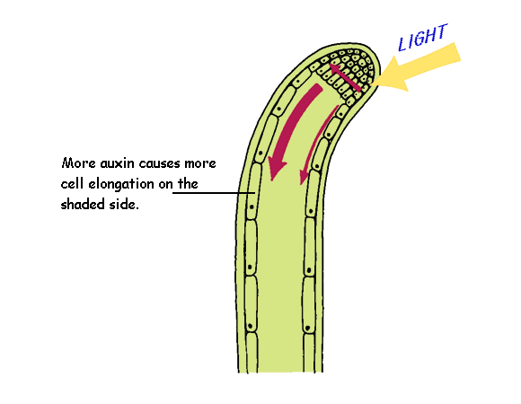
Mechanism of a Plant Response
E.g. positive phototropism of a stem to unilateral light.
Auxin is produced in the apical meristem of the stem.
In unilateral light more auxin moves to the shaded side of the stem.
There will be an unequal distribution of auxin in the elongation zone.
The shaded side will have a higher auxin concentration. High auxin concentration in stems stimulates cell elongation.
The shaded side cells are stimulated to greater elongation than the cells on the other side. This unequal growth causes the stem to bend towards the light.

Synthetic or manmade Plant Growth Regulators
Rooting Powder: increase the success of stem cutting by promoting extensive early rooting. Cytokinin: use in tissue culture to stimulate cell differentiation. Ethelene: quick ripening of mature ‘green bananas’ for the market. Auxin: as a selective weed killer to reduce competition and so promote crop growth.
Plant Protection Adaptations
Cuticle: protection against leaf infection by bacteria, fungi and viruses.
Cork: protection against insect pest damage. Cuticle and Stomata Closure: protection against excessive water loss. Stinging Dermal Hairs: protection against ‘large’ herbivores. Spines and Thorns: protection against ‘large’ herbivores. Heat Shock Proteins: prevent specific proteins from denaturing so they remain functional.

To investigate the effect of IAA concentration on the growth of plant tissue.

Preparation of Auxin Solutions
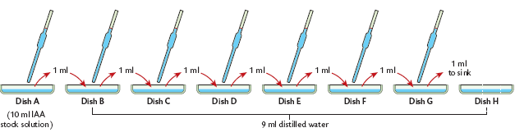
Prepare a stock solution of 10² ppm IAA solution. This has 100 mg of IAA per Litre. Label 8 petri dishes A to H. Using a syringe add 10 ml of 10² IAA into dish A. Place 9 ml of distilled water into each of the other dishes. Use a dropper to transfer 1 ml of solution from dish A to dish B and mix. This creates a 10¹ IAA solution in dish B. Use a clean dropper each time transfer 1ml of IAA from dish B to C and then from C to D, from D to E, from E to F and from F to G. Remove 1 ml from dish G and discard down the sink. Remember dish H has 9 ml of water only and acts as the control.

Investigate the Effect of Auxin on Plant Tissue
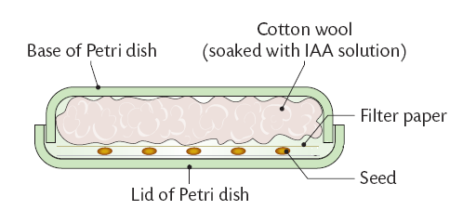
Place the lids of each dish upside down beside the bases. Place 5 radish seeds in a row on each lid. Cover the radish seeds with filter paper and then cotton wool. Pour the contents of each base onto the cotton wool and place the base in position onto the upside down lid and tape it shut. Stand the 8 dishes on edge in a warm incubator at 20 degrees for 4-5 days. Attach a clear acetate grid to the base of each grid and use it to record the average root length of the seedlings in each dish.
Compare the root growth of each IAA concentration with that in dish H
Calculate the % stimulation for each dish as follows
Graph the results showing IAA concentration on the horizontal axis and % stimulation on the vertical axis.

Result
Certain concentration of IAA cause the roots to grow longer than they would have in water. These concentrations give a positive stimulation. Other IAA concentrations cause the roots to grow less than they would in water. These give a negative stimulation or inhibition.

